# Lab Week 1

This semester you’ll be using git to submit your assignments. Git is a source code control system for managing changes to files. We’ll be using github classroom. For each lab assignment this semester your instructor will post a link that has the assignment. Employers want you to have a good understanding of Source code control and tools. This is your first step in that direction.

You may want to bookmark the git cheatsheet. <https://education.github.com/git-cheat-sheet-education.pdf> We will only be using a few commands this semester

|  |  |
| --- | --- |
| Command | Action |
| git clone [url] | Clones the git repository to your location machine |
| git add [file] | Adds the file into to the commit stage. Anytime a file is changed you want to add it for the next commit |
| git commit -m “message” | Commits all the changes with the message given |
| git push | Pushes the current branch back to the repository. |
| git status | Returns the status of all files, controlled and uncontrolled |

; clone, add, commit and push. You’ll also need to be able to work in directories with command line tools. In windows, you’ll want to familiarize yourself with bash commands.

|  |  |
| --- | --- |
| Command | Action |
| cd path | Changes directory to the one given. Can be relative or full path |
| ls | Lists files in a directory |

1. Create an account on <http://www.github.com> You will need to use your official UMKC email address. It must match the email address for the classroom.
2. [Optional] Once you’ve created a github account you can request private repositories. This is optional, but you may want to start using github on your own. Having private repositories allows your work to remain invisible to the public. You can visit <https://education.github.com/pack> to get free private repositories while you are a student.
3. This guide will assume you use git command line on the lab computers. You can download git from <https://git-scm.com/>

Each week you’ll have a new link for the assignment. You’ll use the following directions each week with the URL given for the weeks assignment on Canvas

1. After navigating to the URL given for the week click on Accept this assignment

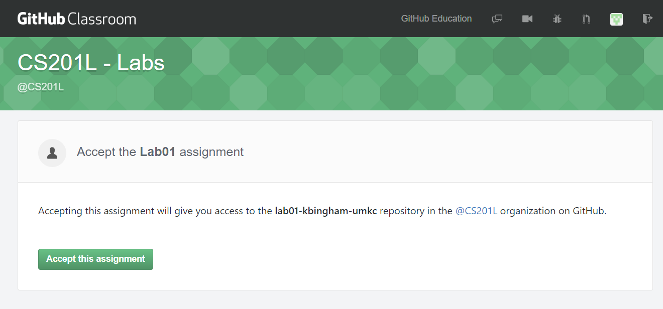

Once you’ve accepted the assignment, it will begin creating your repository

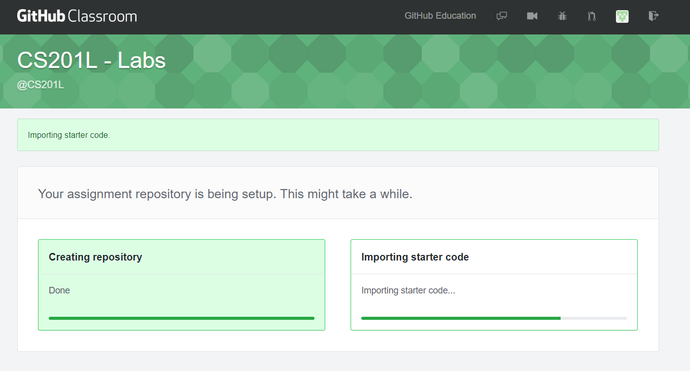

Click on the link for your assignment has been created here..

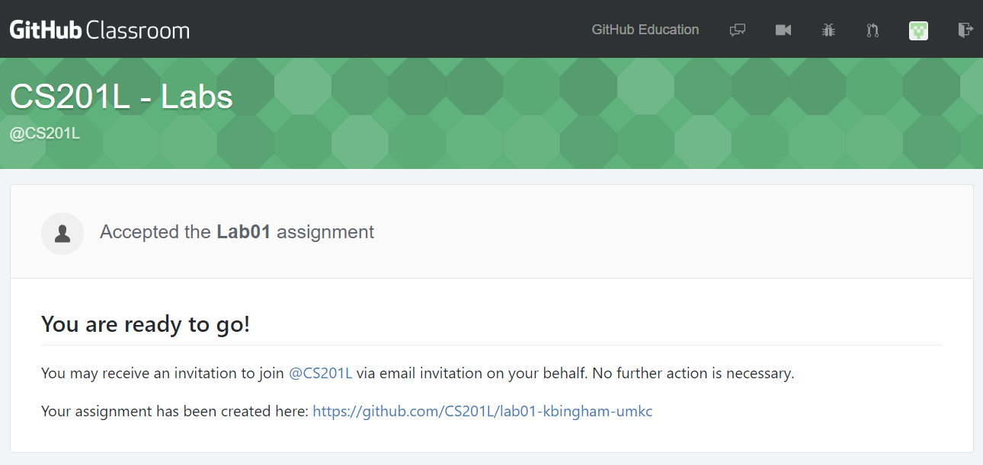

Once in your repository click Clone or Download, then copy down the repository address. You’ll use this later for cloning the repository.

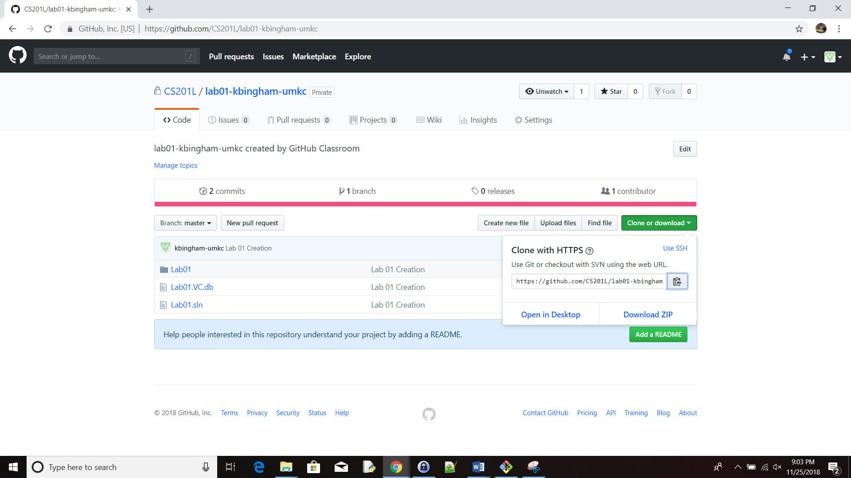

1. Start git BASH. On windows go to start GIT and then click on GIT BASH.
2. Use cd to change to the directory you want to put your work in.

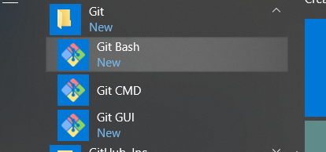

1. The git BASH window is a command line window and looks like the following.

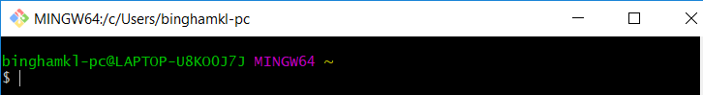

1. You can type commands at the prompt. ls<enter> to view the contents of the current directory. cd to change to a new directory. Go ahead change to a directory where you want to put your lab assignments.
2. Once you are in a directory to put your repository

Type, instead of <url> enter the repository clone address you got above. Replace xx in labxx with the number for the current week lab.

git clone <url> labxx

1. Once your repository is cloned type the following, replacing labxx with the week you are in.

cd labxx

1. Now open the .sln file in this directory with Visual Studio 2015, or the C++ compiler of your choice.
2. In this first assignment, change the calculation for time to correctly calculate the time. Run and test your program. Once you’ve are finished, save all of your work and return to the bash command window. In Solution Explorer on the right open Solution, then Lab01, then Source files. You’ll see the Lab01.cpp file, double click on it and it will open in the window.

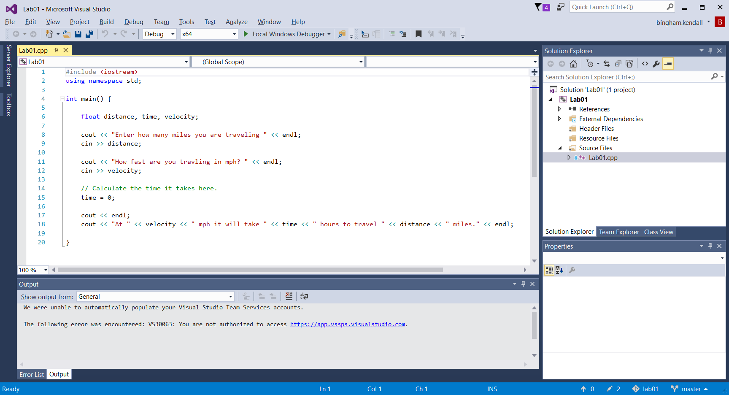

1. **Keeping the console window open after the program runs.** When you run the program in debug mode Ctrl-F5 you may notice the console window closes before you can see the results of the program. To keep this from happening in Visual Studio follow the next steps.
   1. Right click on Lab01 project as shown below. Go down and select properties at the bottom of the menu.

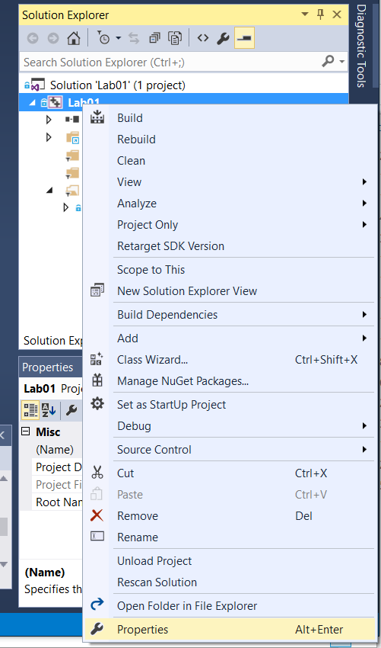

* 1. With the property window open, select Linker, then System on the left. Open the SubSystem drop down box and select console. Hit ok, and your debug console window should remain open after your code runs. Make sure the configuration is set to All Configurations.

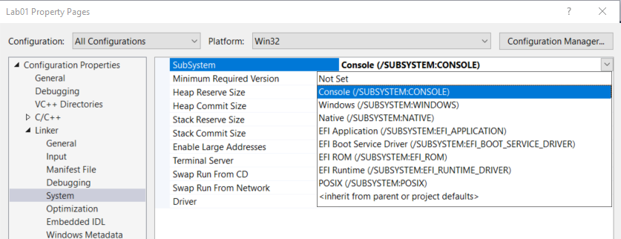

1. In git bash shell type the following line to see the status of the local repository.

git status

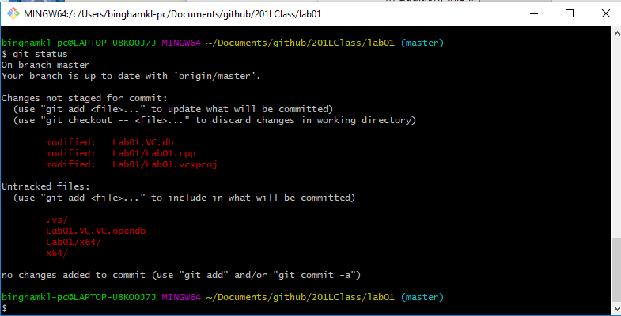

You’ll notice that we have changes staged, and untracked files. Untracked files are files that the source control isn’t keeping track of. If you add a new file that needs to be tracked, then you can use the git add command to add the file.

The files we’ve changed show up in changes not staged. We use the git add command to stage these.

1. In the git bash we first need to add all the files that have been changed

git add Lab01/Lab01.cpp

1. Run git status again and you should see the changes that need to be committed.

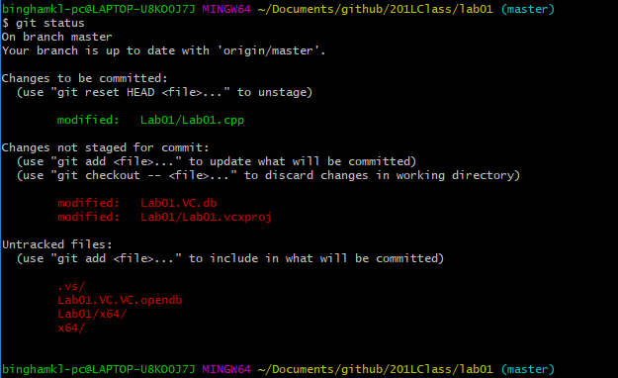

Notice that we now have changes that need to be committed. Lab01.cpp is in the staged area, but is not committed to our local repository.

1. Then we need to commit those changes to our local repository. You can use whatever message you want in between the “” It should be something that is descriptive to what you have just committed.

git commit -m "Push the new change"

1. Run git status again. You should see something like the following.

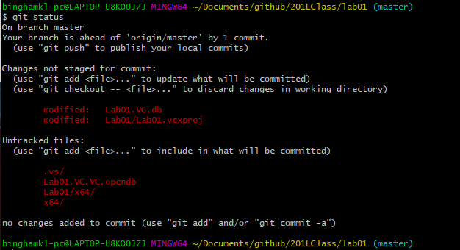

Notice that our branch is ahead of the master remote repository. Our local repository is up to date, but the remote one has not been updated yet.

1. The only thing left is to push the solution to github repository.

git push

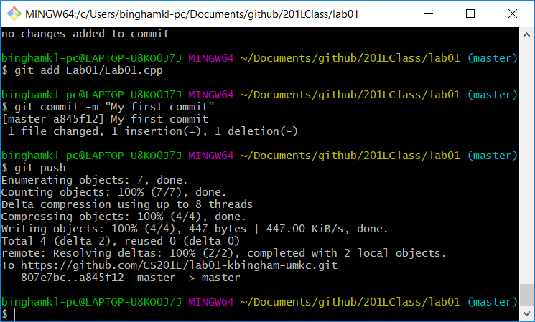

1. Use git status and you’ll notice that you are no longer ahead of the origin/master repository
2. Go back to the github link you got for your repository and refresh it, you should be able to view your changes and see that your work has been pushed to github

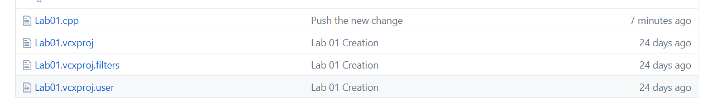

1. You can use git add, git commit and git push as many times you need while you are working on a project.

The general git processes

